COURSE FULL? JOIN THE WAITLIST

You may face the dilemma of preferred class sections being full during registration. In this case you’ll either have to choose a different section of the course, watch for an opening in the preferred section, or not take the course at all that semester. Some departments on campus maintain waitlists in designated sections based on departmental requests to the Office of the Registrar.

HOW DO I KNOW IF A CLASS HAS A WAITLIST?

The waitlist information will appear as shown in the highlighted area on a class section in the Schedule of Classes. If a class does not have a waitlist it will not be listed here.
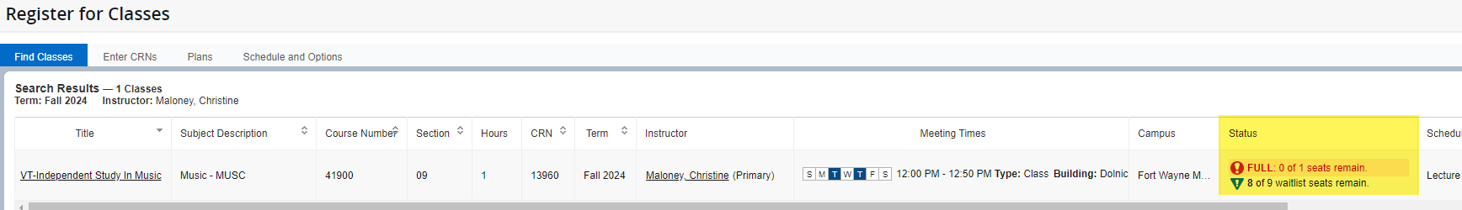

HOW DO I ADD MYSELF TO A WAITLIST?
Click the add button in the right most column of the desired section. This will add the course to your summary. In the “action” column in the summary, change the dropdown to waitlist. Then you must click submit to add yourself to the waitlist. If this option is not available, the waitlist either doesn’t exist or is full. Refer back to the status column highlighted above to check this info.
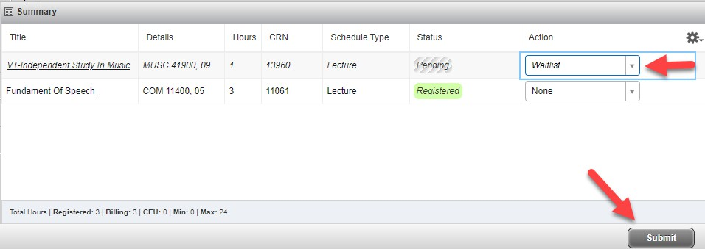

Once you have successfully been added to the waitlist, you will see waitlisted in green:

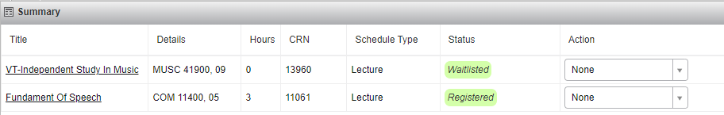

*If section and waitlist are both full.
“FULL” indicates that no regular seats are available. “0 of x waitlist seats remain” indicates that no wait-list seats are available. You may not register or wait-list this class.
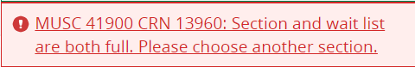

HOW WILL I BE NOTIFIED OF AN OPENING IN THE CLASS?

When a seat becomes available in a class, the first person on the waitlist for that class will receive a system-generated email to their Purdue Fort Wayne email account. It is essential that you check your Purdue Fort Wayne email daily. Here is an example of the email:
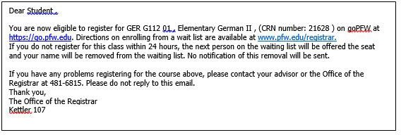

You have 24 hours to enroll in the class section in goPFW. After 24 hours from your time stamp on the waitlist, you will be dropped from the waitlist, and the next student on the waitlist will be offered the seat. No notification of this drop will be sent. Please be sure to monitor your junk email. If you have been dropped from the waitlist and wish to be re-added, please use steps 1-4 to get re-added to the waitlist.

HOW DO I ENROLL WHEN NOTIFIED?
Go to the Add/Drop Classes page on goPFW. Click on the drop-down arrow in the Action column for the class you wait-listed that is now available. Choose Web Registered. Click on the Submit Changes button below.

Your status will change to Web Registered on this page, indicating that you have successfully enrolled.

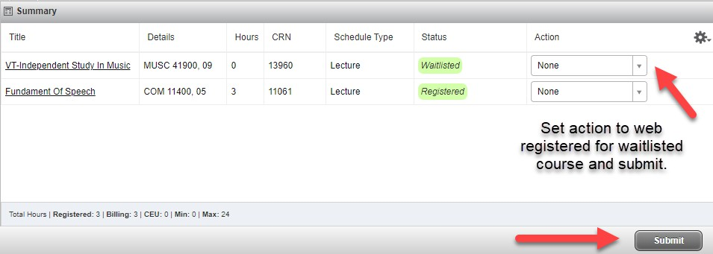

IMPORTANT DETAILS
Please keep the following information in mind about registering.

Holds
Make sure that you do not have registration holds on your goPFW account. A hold will prevent you from enrolling or placing yourself on a waitlist.

Registration Restrictions
Waitlists will enforce the same registration restrictions when it comes to prerequisite or corequisite courses as regular enrollment. You must have the needed prerequisite or corequisite courses to wait-list. Another wait-listed course will not count as a prerequisite or corequisite.

Multiple Sections
You can only waitlist one section of a course. You can be enrolled in one section and wait-list a different section of a course, but only one.

Fees
Fees are not assessed for wait-listed class sections. Fees are assessed only if you register for a class section.

Dropping
Please be considerate of your fellow students. If you decide you no longer want a wait-listed section, please drop it as you would drop an enrolled section.

HOW LONG ARE THE WAITLISTS AVAILABLE DURING A TERM?
The waitlist functionality is turned off at 5:00 p.m. on the Friday (census) at the end of the first week of classes in the term for Fall and Spring and the Friday before classes begin for Summer. All students will be purged from the waitlists at that time.

WHERE CAN I FIND WHAT MY POSITION IS ON THE WAITLIST?

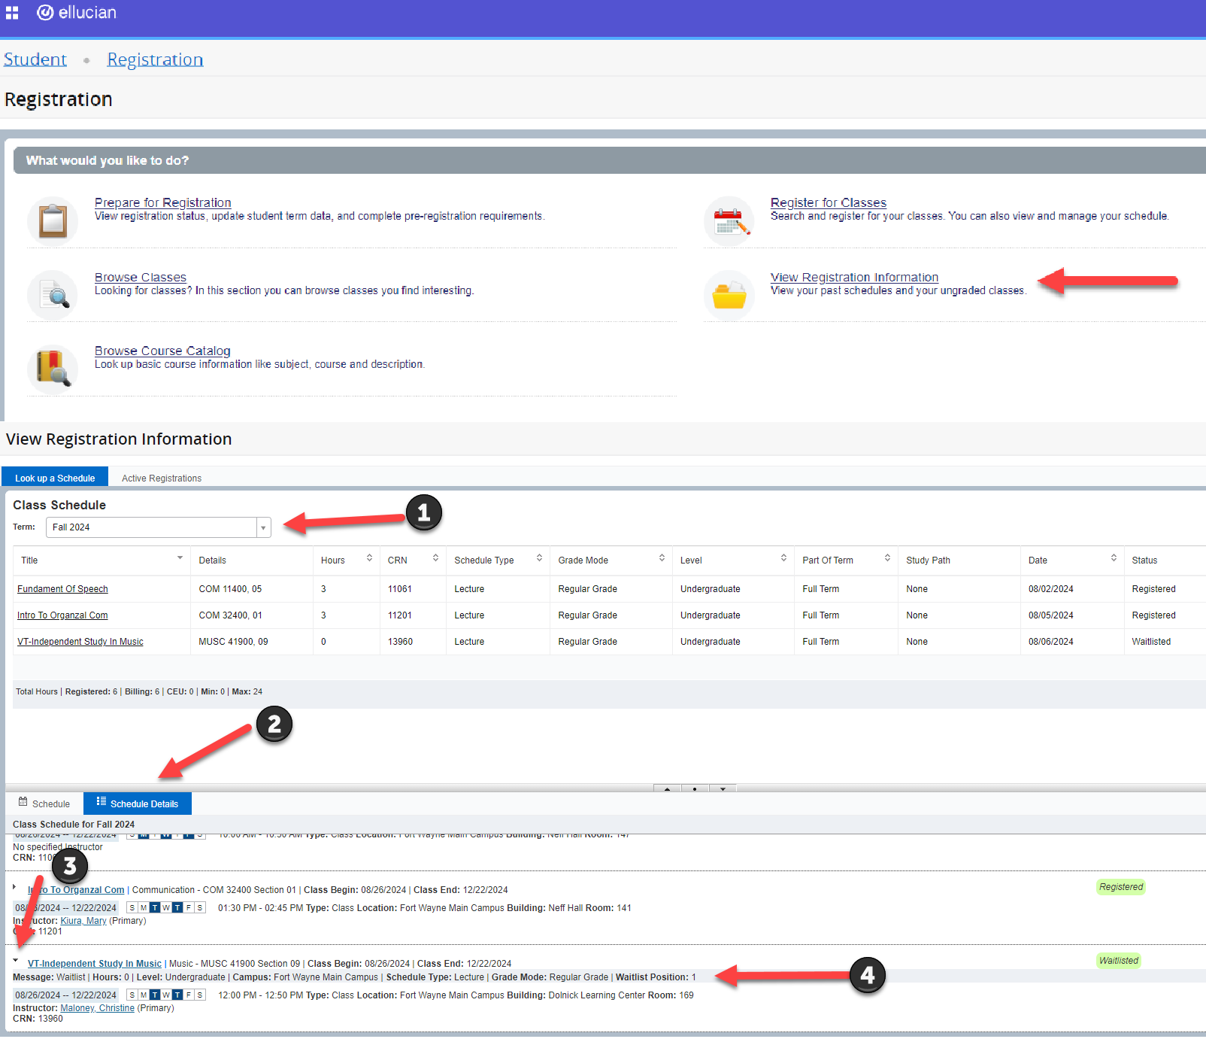

Go to “View Registration Information,” select the correct term in look up a schedule, and select “Schedule Details” in the bottom half of the screen. Expand the course details using the arrow next to the course to view “Waitlist Position.”

WHO DO I CONTACT IF I HAVE QUESTIONS?
You can contact the Office of the Registrar at 260-481-6815 or registrar@pfw.edu, or the department offering the course, if you have questions about waitlisting.

