
Office of the Registrar

Purdue University Fort Wayne categorizes classes using one of three instructional modalities: in person, online and hybrid. All class sections should be appropriately identified using the definitions below. Instructional modalities provide critical information to students by setting expectations for their learning experiences. Accurate use of instructional modalities also ensures PFW’s ability to accurately report methods of class delivery to Federal and state agencies.

In-Person
Definition:
Traditional campus-based face-to-face instruction in a classroom.
Schedule of Classes:
Appears with no letter on the section number. Section has days, times, and a room location.
Schedule Type:
Most commonly Lecture (LEC), Lab (LAB), Studio (SD), etc.
Sample Class Text:
No class Text needed.

Example:

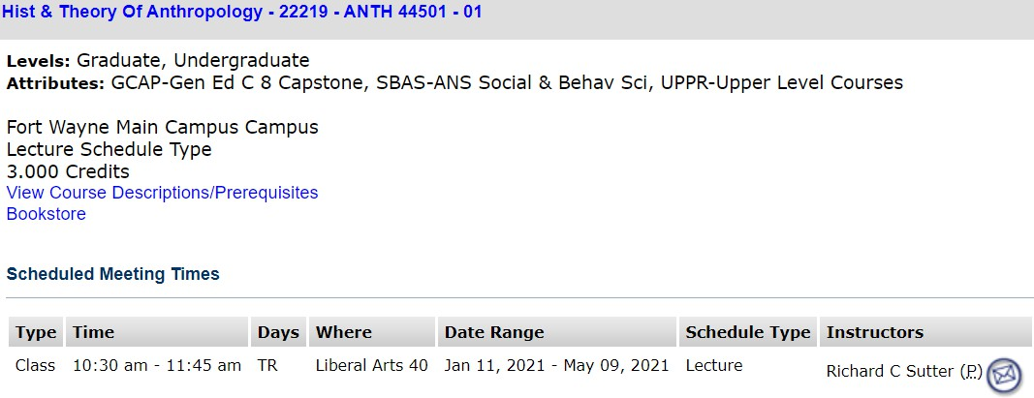

Online
Definition(s):
- Instruction is provided entirely through asynchronous online education. No on-campus meetings are required.
- Instruction is provided through a combination of asynchronous and synchronous online education. No on-campus meetings are required.
- Instruction is provided entirely through synchronous live video instruction. No on-campus meetings are required.
- Student is required to come on campus for proctored testing but all instruction is taught through asynchronous, synchronous, or a combination of asynchronous/synchronous online/video education.
Schedule of Classes:
Appears with the letter ‘I’ on the section number. Scheduled Meeting Times will display no meeting days listed, time displays as TBA, and Where (Room) would show Internet Class. Campus Location and Schedule Type will appear as Distance Education, Instructional Method will display Online 100% or Online 76-99% (See Text)
Schedule Type:
Distance Education (DIS)
Sample(s) of Class Text:
- Internet Required; Access Course Through E-Learning
- Synchronous Section; Internet Required; Access Course Through E-Learning; Students Are Required to Attend Online at The Class Meeting Times, Tuesdays, Thursdays, 12:00-1:15 PM; Contact Instructor for Additional Information
- Internet Required; Access Course Through E-Learning; Section Requires Proctored Testing

Example:
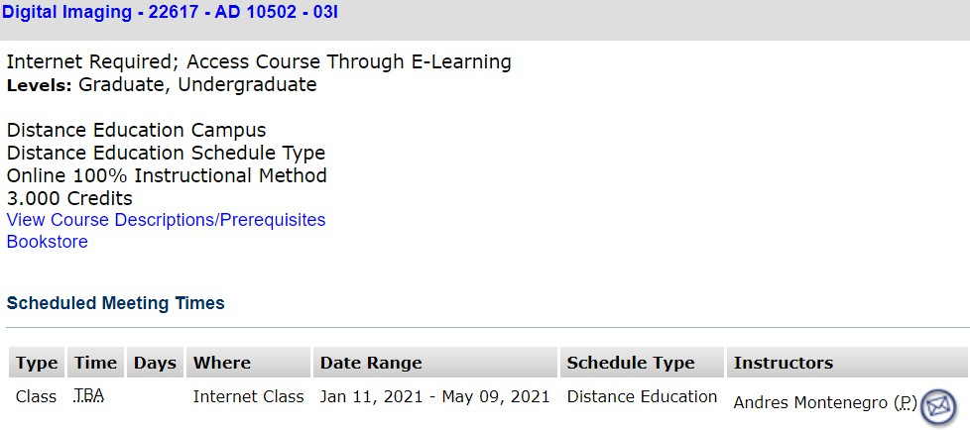

Hybrid
Definition(s):
- Some instruction is provided through asynchronous or synchronous online instruction. The remainder of the instruction is provided through traditional face-to-face instruction. Regular on-campus meetings are required. (Full roster or partial roster may be assigned to attend each on-campus meeting.)
- Some instruction is provided by synchronous live video instruction. The remainder of the instruction is provided through traditional face-to-face instruction. Regular on-campus meetings are required. (Full roster or partial roster may be assigned to attend each on-campus meeting.)
- Primary instruction is provided through asynchronous online education and/or synchronous live video instruction. Occasional on-campus meetings are required throughout the semester. (Full roster or partial roster may be assigned to attend each on- campus meeting.)
Schedule of Classes:
- Pre-planned - On Schedule of Classes, appears with the letter ‘M’ on the section number. Has two meeting times – one with days, times and room location; and one with no days, TBA time, and online location. Schedule Type is most commonly Lecture, Lab, or Studio. Instructional Method is Hybrid of Classroom and Online. Campus is Distance Education, and Instructional Method is Hybrid of Classroom and Online.
- Instructor’s Choice (no notification) – On Schedule of Classes, appears with no letter on the section number. Has days, time, and room location. Schedule Type is most commonly Lecture (LEC), Lab (LAB), or Studio (SD). (Class Text not updated due to no notification.)
- Instructor’s Choice (with notification) – Set up could be like either of the above, depending on timing of notification and information provided by department/instructor. (Class Text updated with notification.)
Schedule Type:
Most commonly Lecture (LEC), Lab (LAB), or Studio (SD), etc.
Sample(s) of Class Text:
- Hybrid Section; Internet Required; Access Course Through E-Learning; Plus On Campus Meetings TBA
- Hybrid Section; Internet Required; Access Course Through E-Learning; Plus On Campus Meetings; See Course Syllabus For Meeting Dates
- Hybrid Section; Internet Required; Access Course Through E-Learning; Plus On Campus Meetings, Tuesdays, 10:30-11:45 AM
- Hybrid Section; Internet Required; Access Course Through E-Learning; Synchronous Online Meetings; Students Are Required to Attend Online Tuesdays, Thursdays, 6:00-7:15 PM; There will Be Four On-Campus Meetings, Tuesdays, Thursdays, 6:00-7:15 PM; On Campus Dates and Room TBA
- Hybrid Section; Internet Required; Access Course Through E-Learning; Plus On Campus Meetings Tuesdays or Thursdays; Group Assignments for Which Days You Will Attend Will Be Made the Week Before the Semester Starts
- Hybrid Section; Internet Required; Access Course Through E-Learning; Synchronous Online Meetings; Students Are Required to Attend Online at The Class Meeting Times, Fridays, 8:00 - 11:50 AM; Plus On Campus Meetings; Dates TBA; Contact Instructor for Additional Information
- Hybrid Section; Internet Required; Access Course Through E-Learning; Plus On Campus Meetings; Half of The Class Will Meet on Tuesdays and Half of The Class Will Meet on Thursdays; The Rest of The Course Work Will Be Done Online; The Instructor Will Determine Who Attends on Which Day
- Hybrid Section; Internet Required; Access Course Through E-Learning; Plus On Campus Meetings on Alternating Days
- Hybrid Section; Internet Required; Access Course Through E-Learning; On Campus Meetings Mondays, Plus Synchronous Online Meetings, Mondays, 3:00 - 4:15 PM
- Hybrid Section; Internet Required; Access Course Through E-Learning; Plus On Campus Meetings; Plus Synchronous Online Meetings; Students Are Required to Attend Online, Mondays, Wednesdays, 9:00 - 9:50 AM

Example:
