**Build Content Practice with AI using Lumi**

# Overview

# Instructors can enhance their course content by embedding interactive tools, known as Elements and Practices, directly into Brightspace Content Files. These files are accessed using the “Create a File” option in Content. These tools help engage students by organizing the content in manageable sections and providing students with dynamic learning experiences.

# Elements: Interactive learning tools that deepen student comprehension by connecting them with course concepts.

# Practices: Tools that offer opportunities for prior knowledge assessment, concept exploration, or self-assessment.

# Layouts: A feature to organize course content using columns, allowing instructors to arrange text, images, and videos for clearer presentation.

# Tips When Working with Existing Content

This guide can be used to create new content files or build elements using existing content files. Refer to these steps if you already have content files built in your course. Then use the guide for more detailed instructions on building **Elements** and **Practice** into your content files.

1. Open the existing content file. (Click Edit HTML.)
2. Identify the section of content that you plan to use to build the new element.
3. Copy that section of content.
4. Place your cursor in the location of the page for the new element.
5. Click **Creator+ Authoring Tools** menu in the Brightspace Editor.
6. Select **Insert Element** from the menu.
7. Begin building your element. (see Part 1 for more details)
8. Once you are happy with the new element, delete the original content, if no longer needed.

# Objectives

By following the guide, you will be able to:

Part 1: Generate Practice Questions using D2L AI Tool Lumi for Creator+ (includes editing)

# Part 1: Generate Practice Questions using D2L Lumi for Creator+

When building in practice exercises in Content, you may sometimes find it helpful to generate practice questions using AI (Lumi). The Lumi tool is most effective under the following criteria:

* The selected content must be either an HTML topic, media topic with English-based captions, or most file types excluding PDF.
* D2L recommends input submitted to D2L Lumi be in English. Brightspace does not prevent non-English language content from being submitted as input.

1. Locate the existing module and topic.
2. Open the existing content file. (Click Edit HTML.)
3. Identify the section of content that you plan to add a practice question.
4. Place your cursor in the location of the page for the new element.
5. Click the **Creator+ Authoring Tools** overflow menu in the Brightspace Editor.
6. Select **Insert Practice** from the menu.

1. Select the type of Practice from the available list.
2. Click **Generate Question**.  
   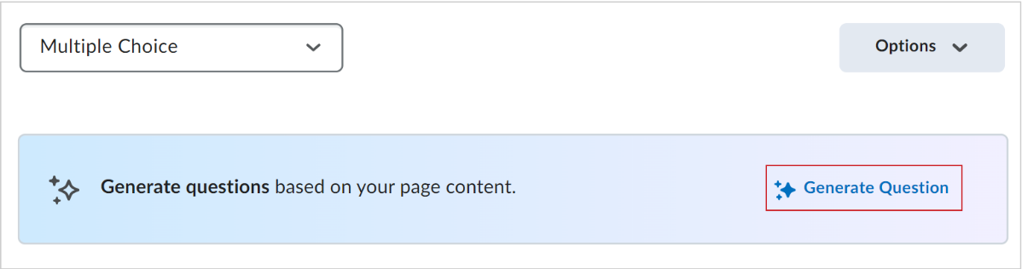
3. Lumi will collect source text from your content page.
   * You can edit the text if you wish to change/narrow the amount of content it will use to generate a practice question. Eding this ‘Source Text’ will not alter your content.   
       
     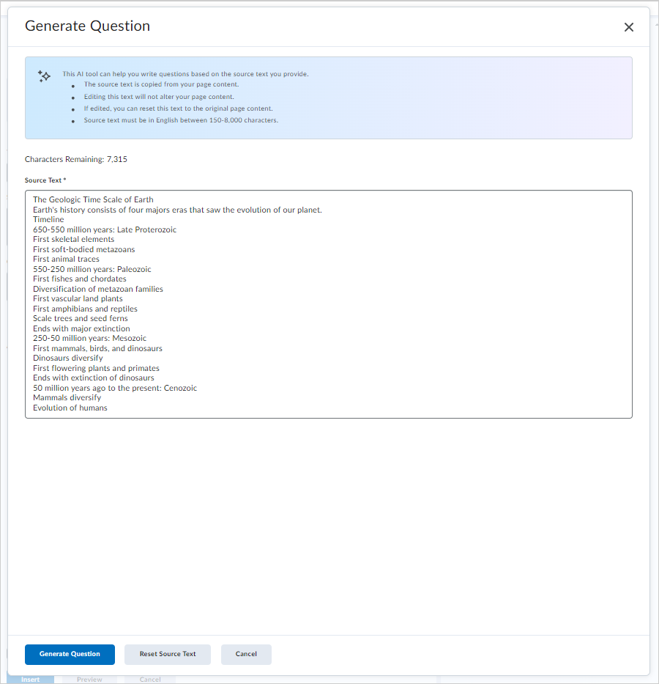
4. When your Practice question generates, review the question and perform one of the following actions:
5. **Regenerate Question:** Click to generate a new question.
6. **Edit Source Text:** Click to edit the **Source Text** and then click **Regenerate Question**.
7. **Discard Question:** Delete the generated Practice question.
8. Optionally, rate the question quality by selecting the thumbs up or thumbs down.

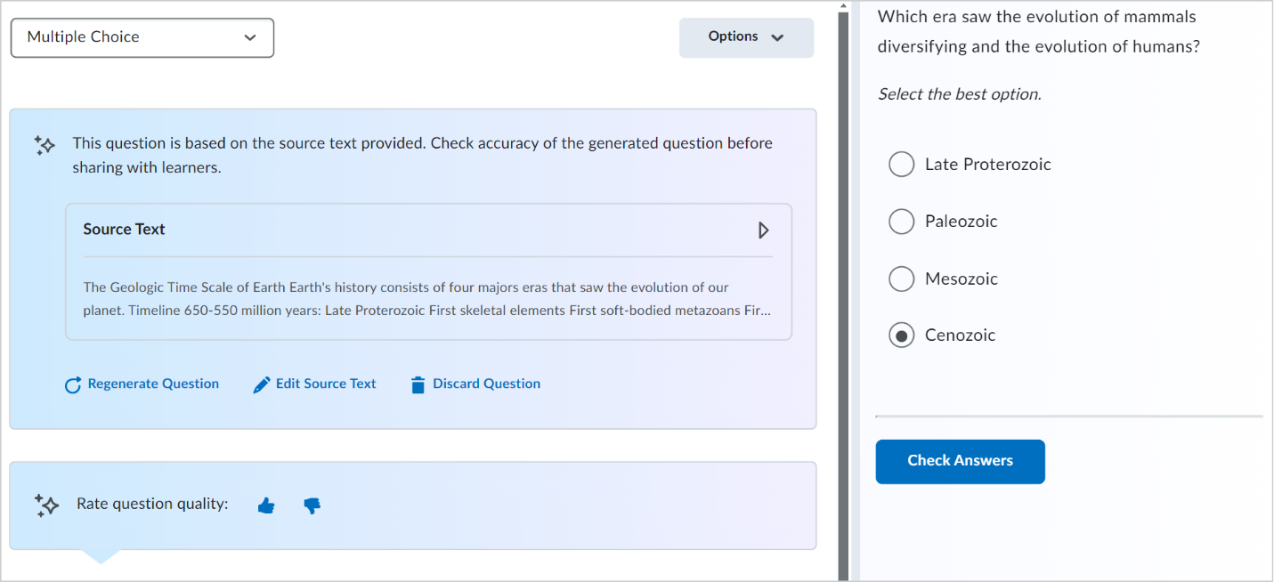

1. When satisfied with the question, click **Insert**.
2. Select the **Close** (X) icon in the dialog after your Practice is inserted.
3. Click **Save and Close** for your Content topic.

**Editing your AI-Generated Practice**

1. Click **Edit HTML**.
2. Click anywhere on the element for the editing tools to appear.
   * Click the pencil icon to edit the element.
   * Click the trashcan icon to delete the element.
   * Click the arrows to move the element up/down on the content page.
   * Note: If you delete an element by accident and have not yet saved, you can use the ‘undo’ arrows in the editor toolbar.

1. To return to the ‘Source Text’, click the ‘Generate Question’ link. (Note: This will not generate a new question but merely display the source text.)
2. When your Practice question generates, review the question and perform one of the following actions:

* **Regenerate Question:** Click to generate a new question.
* **Edit Source Text:** Click to edit the **Source Text** and then click **Regenerate Question**.
* **Cancel:** Return to the practice question editing page.

1. To exit, click the **Insert** if you made changes or **Cancel**.
2. Select the **Close** (X) icon in the dialog after your Practice is inserted.
3. Click **Save and Close** for your Content topic.