**Build Content Practice with Creator+**

# Overview

# Instructors can enhance their course content by embedding interactive tools, known as Elements and Practices, directly into Brightspace Content Files. These files are accessed using the “Create a File” option in Content. These tools help engage students by organizing the content in manageable sections and providing students with dynamic learning experiences.

# Elements: Interactive learning tools that deepen student comprehension by connecting them with course concepts.

# Practices: Tools that offer opportunities for prior knowledge assessment, concept exploration, or self-assessment.

# Layouts: A feature to organize course content using columns, allowing instructors to arrange text, images, and videos for clearer presentation.

# Tips When Working with Existing Content

This guide can be used to create new content files or build elements using existing content files. Refer to these steps if you already have content files built in your course. Then use the guide for more detailed instructions on building **Elements** and **Practice** into your content files.

1. Open the existing content file. (Click Edit HTML.)
2. Identify the section of content that you plan to use to build the new element.
3. Copy that section of content.
4. Place your cursor in the location of the page for the new element.
5. Click the **Creator+ Authoring Tools** menu in the Brightspace Editor.
6. Select **Insert Element** from the menu.
7. Begin building your element. (see Part 1 for more details)
8. Once you are happy with the new element, delete the original content, if no longer needed.

# Objectives

By following the guide, you will be able to:

Part 1: Insert Practice Features in Content Pages

Part 2: Edit Element or Practice Features in Content Pages

# Part 1: Insert Practice Features in Content File

1. Click **Content** in the navigation bar.
2. Create a new module or open an existing module.
3. Create a new content topic or open an existing content topic.
   * To create a new content topic:
     1. Click the **Upload/Create** button.
     2. Select **Create a File** in the menu.
   * To edit an existing content topic:
     1. Click the down-arrow to the right of the file and select **Edit HTML**.
4. Place your cursor in the location of the page for the new element.
5. Click the **Creator+ Authoring Tools** menu in the Brightspace Editor.
6. Select **Insert Practice** from the menu.

1. Select the practice you want to create from the available list, and then complete the fields to configure the practice. Refer to the Practice Options below.

# Practice Options:

* **Note**: Practice elements are only intended to provide the learner with immediate feedback. Scores are not saved or tracked.
* **To Edit, refer to:** Part 2: Edit Element or Practice Features in Content Pages.

**Dropdown Fill in the Blanks**

This Fill in the Blanks option presents learners with a statement that has one or more blanks, each with providing options to choice in a dropdown format. The options include one correct answer and one or more incorrect answer(s).

1. Add a **Title**, **Short Description**, and **Instructions**. (optional)

(Note: The **Short Description** field is visible only to Content Editors when editing the Content Topic.)

1. Add your **Question Text**. To create a ‘fill in the blank’ space, type the word 'blank' and a number inside double square brackets, for example, [[blank1]].

1. Click **Update Blanks**.
2. Add the **Correct Answer**.
3. Click **Add Alternative Answer** to enter incorrect options. Repeat as needed. (To delete an answer, click the Trashcan icon.)

1. In the **How will this practice be scored?** field, choose one of the following options: All or Nothing (default), Correct Inputs, right Minus Wrong Inputs
2. Use the side panel to preview and check answers or click the **Preview** button.
3. When satisfied with the element, click **Insert**.
4. Click the **X** button to close the Practice interface.

**Fill in the Blanks**

1. Add a **Title**, **Short Description**, and **Instructions**. (optional)

(Note: The **Short Description** field is visible only to Content Editors when editing the Content Topic.)

1. Add your **Question Text**. To create a ‘fill in the blank’ space, type the word 'blank' and a number inside double square brackets, for example, [[blank1]].

1. Click **Update Blanks**.
2. Add the **Correct Answer**.
3. Click **Add Alternative Answer** to enter incorrect options. Repeat as needed. (To delete an answer, click the Trashcan icon.)

1. In the **How will this practice be scored?** field, choose one of the following options: All or Nothing (default), Correct Inputs, right Minus Wrong Inputs
2. Use the side panel to preview and check answers or click the **Preview** button.
3. When satisfied with the element, click **Insert**.
4. Click the **X** button to close the Practice interface.

**Multi-Select**

1. Add a **Title** & **Short Description.** (optional)  
   (Note: The **Short Description** field is visible only to Content Editors when editing the Content Topic.)
2. Add your **Question Text**.
3. If you want to include an image, click **Add Image**. Select an image file and add **Alternative Text** or indicate that the image is decorative. Then, click **Save**.
4. Use the **Add Answer** link to add answers. Repeat as needed. To delete an answer, click the **Trashcan** icon.
5. Select all correct answers by checking the box.

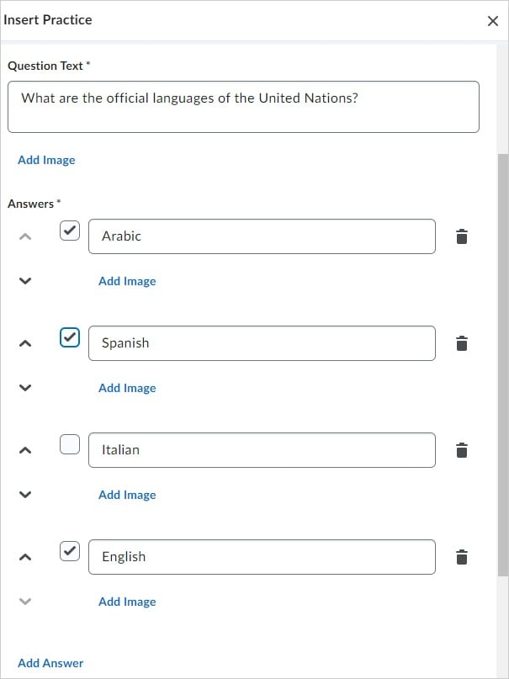

1. To randomize the answer order, select **Randomize answer order**.
2. In the **How will this practice be scored?** field, choose one of the following options: All or Nothing (default), Correct Selections, right Minus Wrong Selections
3. Use the side panel to preview and check answers or click the **Preview** button.
4. When satisfied with the element, click **Insert**.
5. Click the **X** button to close the Practice interface.

**Multiple Choice**

1. Add a **Title** & **Short Description**. (optional)

(Note: The **Short Description** field is visible only to Content Editors when editing the Content Topic.)

1. Add your **Question Text**.
2. If you want to include an image, click **Add Image**. Select an image file and add **Alternative Text** or indicate that the image is decorative. Then, click **Save**.
3. Use the **Add Answer** link to add answers. Repeat as needed. To delete an answer, click the **Trashcan** icon.
4. Select the correct answer by checking the box. (Only one correct answer.)

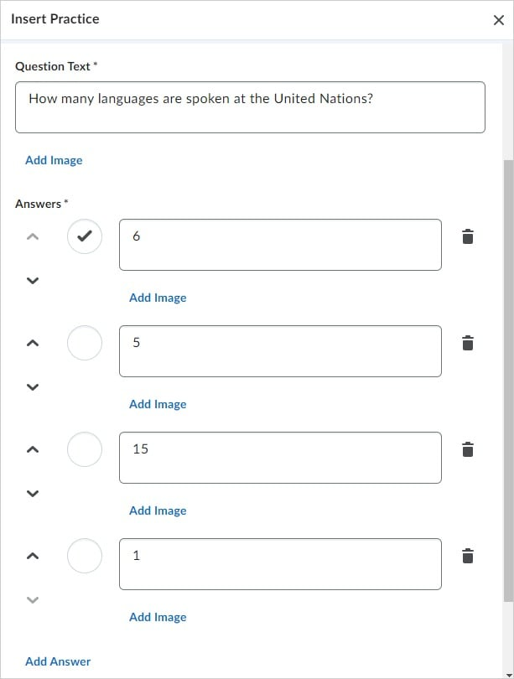

1. To randomize the answer order, select **Randomize answer order**.
2. Use the side panel to preview and check answers or click the **Preview** button.
3. When satisfied with the element, click **Insert**.
4. Click the **X** button to close the Practice interface.

**Sequencing**Sequencing Practice is a great way to help students practice comprehension of a process. It can be used to reinforce the correct order of steps. Feedback can also be built in to indicate why each step was correct or incorrect.

1. Add a **Title**, **Short Description**, and **Instructions**. (optional)

(Note: The **Short Description** field is visible only to Content Editors when editing the Content Topic.)

1. To have the sequence numbered, click the **Display Numeric Sequence** check box.
2. Add a **Sequence Step** and **Sequenceable Item** for each Sequence Step.
3. Additionally, you have the following options:
   * There are four Sequence Steps by default.
   * To delete a Sequence Step, click the Trashcan icon.
   * To add additional Sequence Steps, click **Add Sequence Step**.
4. If you want to include an image, click **Add Image**. Select an image file and add **Alternative Text** or indicate that the image is decorative. Then, click **Save**.
5. Use the side panel to preview and check answers or click the **Preview** button.
6. When satisfied with the element, click **Insert**.
7. Click the **X** button to close the Practice interface.

**Sorting**

Sorting Practice helps learners make connections by organizing items into different categories by dragging the “Sortable Items” under the correct Category. Students are able to check their answers as well as ‘Try Again’.

1. Add a **Title**, **Short Description**, and **Instructions**. (optional)

(Note: The **Short Description** field is visible only to Content Editors when editing the Content Topic.)

1. To indicate the total number of items in each category, click the **Display Item Count per Category** check box. (This is viewable by the learner.)
2. For each category, add a **Category Label**. Additionally, you have the following options:
   * There are four categories by default.
   * Use the arrow buttons to re-arrange the order of categories.
   * To delete a category, click the Trashcan icon.
   * To add a category, click the **Add Category** link.
   * If you want to include an image, click **Add Image**. Select an image file and add **Alternative Text** or indicate that the image is decorative. Then, click **Save**.
3. To add sortable items to a category, click the **Category** box and while it is selected (highlighted in blue), enter the name of the item. Additionally, you have the following options:

* Each category has one sortable item by default.
* To delete a sortable item, click the Trashcan icon.
* To add additional sortable items to the category, click **Add Sortable Item**.
* If you want to include an image, click **Add Image**. Select an image file and add **Alternative Text** or indicate that the image is decorative. Then, click **Save**.

1. Use the side panel to preview and check answers or click the **Preview** button.
2. When satisfied with the element, click **Insert**.
3. Click the **X** button to close the Practice interface.

**True or False**

1. Add a **Title** and **Short Description** (optional).

(Note: The **Short Description** field is visible only to Content Editors when editing the Content Topic.)

1. In the **Question Text** field, add your statement.
2. In **Answers** section, select if each part of the statement is true or false.

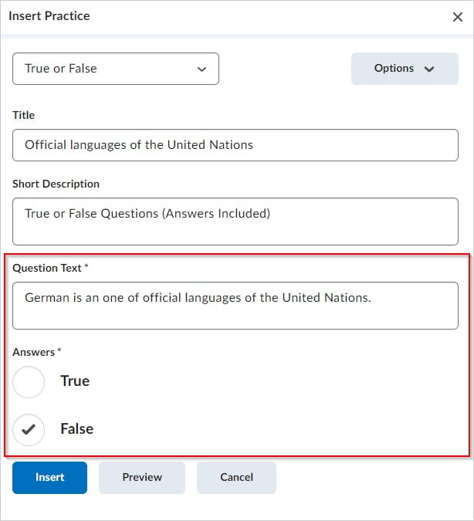

1. Use the side panel to preview and check answers or click the **Preview** button.
2. When satisfied with the element, click **Insert**.
3. Click the **X** button to close the Practice interface.

# Part 2: Edit Element or Practice Features in Content Files

1. Click **Edit HTML**.
2. Click anywhere on the element for the editing tools to appear.
   * Click the pencil icon to edit the element.
   * Click the trashcan icon to delete the element.
   * Click the arrows to move the element up/down on the content page.
   * Note: If you delete an element by accident and have not yet saved, you can use the ‘undo’ arrows in the editor toolbar.

1. Click **Save and Close**.