**Build Content Layouts with Creator+**

# Overview

# Instructors can enhance their course content by embedding interactive tools, known as Elements and Practices, directly into Brightspace Content Files. These files are accessed using the “Create a File” option in Content. These tools help engage students by organizing the content in manageable sections and providing students with dynamic learning experiences.

# Elements: Interactive learning tools that deepen student comprehension by connecting them with course concepts.

# Practices: Tools that offer opportunities for prior knowledge assessment, concept exploration, or self-assessment.

# Layouts: A feature to organize course content using columns, allowing instructors to arrange text, images, and videos for clearer presentation.

# Tips When Working with Existing Content

This guide can be used to create new content files or build elements using existing content files. Refer to these steps if you already have content files built in your course. Then use the guide for more detailed instructions on building **Elements** and **Practice** into your content files.

1. Open the existing content file. (Click Edit HTML.)
2. Identify the section of content that you plan to use to build the new element.
3. Copy that section of content.
4. Place your cursor in the location of the page for the new element.
5. Click the **Other Insert Options** overflow menu in the Brightspace Editor.
6. Select **Insert Element** from the menu.
7. Begin building your element. (see Part 1 for more details)
8. Once you are happy with the new element, delete the original content, if no longer needed.

# Objectives

By following the guide, you will be able to:

Part 1: Insert Layout Panels to Organize Content

# Part 1: Insert Layout Panels to Organize Content

Use the Layouts tool to insert panels that can help structure and organize your course content including text, media, or Creator+ Elements. Layouts can be added to a new or existing content page.

1. Click **Content** in the navigation bar.
2. Create a new module or open an existing module.
3. Create a new content topic or open an existing content topic.
   1. To create a new content topic:
      1. Click the **Upload/Create** button.
      2. Select **Create a File** in the menu.
   2. To edit an existing content topic:
      1. Click the down-arrow to the right of the file and select **Edit HTML**.
4. Place your cursor in the location of the page for the new element.
5. Click the **Creator+ Authoring Tools** menu in the Brightspace Editor.
6. Select **Layouts** from the menu.

1. In the **Format Options** section, select one of the following layout options:

* Two Panels
* Two Thirds / One Third Panels
* One Third / Two Thirds Panels
* Three Panels

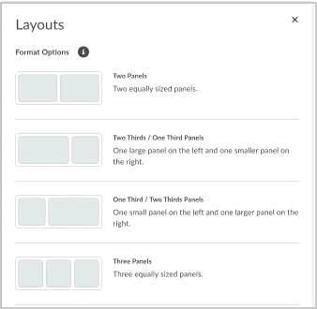

1. You can now begin creating content inside layout. Select a panel to begin adding content using tools from Brightspace Editor.

**To Modify a Layout**

1. In Brightspace Editor, click anywhere on the layout to prompt the context menu.
2. From the context menu, you can:
   1. Move the layout position up or down within the page using the arrows.
   2. Change the layout format by selecting another panel type.
   3. Use **Delete** to delete the layout and all content within the layout.
3. Use **Remove Layout** to remove the layout panels, but keep the existing content.

