**Build Content Elements with Creator+**

# Overview

# Instructors can enhance their course content by embedding interactive tools, known as Elements and Practices, directly into Brightspace Content Files. These files are accessed using the “Create a File” option in Content. These tools help engage students by organizing the content in manageable sections and providing students with dynamic learning experiences.

# Elements: Interactive learning tools that deepen student comprehension by connecting them with course concepts.

# Practices: Tools that offer opportunities for prior knowledge assessment, concept exploration, or self-assessment.

# Layouts: A feature to organize course content using columns, allowing instructors to arrange text, images, and videos for clearer presentation.

# Tips When Working with Existing Content

This guide can be used to create new content files or build elements using existing content files. Refer to these steps if you already have content files built in your course. Then use the guide for more detailed instructions on building **Elements** and **Practice** into your content files.

1. Open the existing content file. (Click Edit HTML.)
2. Identify the section of content that you plan to use to build the new element.
3. Copy that section of content.
4. Place your cursor in the location of the page for the new element.
5. Click the **Creator+ Authoring Tools** menu in the Brightspace Editor.
6. Select **Insert Element** from the menu.
7. Begin building your element. (see Part 1 for more details)
8. Once you are happy with the new element, delete the original content, if no longer needed.

# Objectives

By following the guide, you will be able to:

Part 1: Insert Element Features in Content Pages

Part 2: Edit Element or Practice Features in Content Pages

# Part 1: Insert Element Features in Content Files

1. Click **Content** in the navigation bar.
2. Create a new module or open an existing module.
3. Create a new content topic or open an existing content topic.
   1. To create a new content topic:
      * Click the **Upload/Create** button.
      * Select **Create a File** in the menu.
   2. To edit an existing content topic:
      * Click the down-arrow to the right of the file and select **Edit HTML**.
4. Place your cursor in the location of the page for the new element.
5. Click the **Creator+ Authoring Tools** menu in the Brightspace Editor.
6. Select **Insert Element** from the menu.

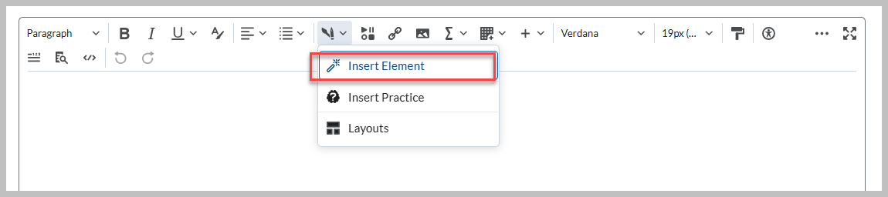

1. Select the element you want to create from the available list, and then complete the fields to configure the element. Refer to the Element Options below.

# Element Options:

**Accordion**

* 1. Select one of the **Format Options** to indicate if you want to number the accordion folders. The default is ‘Unnumbered’.
  2. Enter **Learner Instructions** to ensure that the learners know there is a dynamic element. The default reads: “Select each item to learn more.”
  3. Enter the **Accordion Tab Title** and **Accordion Content** for each accordion tab.
  4. Click **Add Accordion Item** to add more accordions or click the trashcan icon to remove a tab.
  5. Click **Preview**, and when satisfied with the element, click **Insert**. (Use the **Back** button to return to Edit.)

**Tabs**

1. Select one of the **Format Options** to indicate if you want to the tabs to be horizontal or vertical.
2. Enter **Learner Instructions** to ensure that the learners know there is a dynamic element. The default reads: “Select each item to learn more.”
3. Enter the **Tab Title** and **Tab Content** for each tab.
4. Click **Add Tab Item** if you need more tabs or click the trashcan icon to remove a tab.
5. Click **Preview**, and when satisfied with the element, click **Insert**. (Use the **Back** button to return to Edit.)

**Click and Reveal**

1. Select one of the **Format Options** to indicate if you want the click trigger to have a question mark icon (**Question**) or text only (**No Icon**).
2. Add **Introductory Content** to introduce the element.
3. Enter **Learner Instructions** to ensure that the learners know there is a dynamic element. The default reads: “Select to learn more.”
4. Enter the **Button Label** (Default: “Learn More” & “Hide Content”)
5. Enter the **Revealed Content**.
6. Click **Preview**, and when satisfied with the element, click **Insert**. (Use the **Back** button to return to Edit.)
7. Note: Additional **Click and Reveal** elements are made individually by inserting another element.

**Callout**

1. Select one of the **Format Options**. (For more information about each, click the question mark icon beside the option title.)
2. Enter a **Title** and **Callout Content** for your element.
3. If you have more Callout elements to add, click **Back** and add another element.
4. Click **Preview**, and when satisfied with the element, click **Insert**. (Use the **Back** button to return to Edit.)
5. Note: Additional **Callout** elements are made individually by inserting another element.

**Timeline**

1. Select one of the **Format Options** to indicate if you want the timeline to have left-aligned or alternating entries.
2. Enter each **Timeline Panel Title** and **Timeline Panel Text**.
3. Click **Add Timeline Panel Item** if you need more timeline panels.
4. Click **Preview**, and when satisfied with the element, click **Insert**. (Use the **Back** button to return to Edit.)

**Stylized Quote**

1. Select one of the **Format Options** to indicate if you want standard size text or large focus.
2. Enter the **Quotation** and **Attribution**.
3. Click **Preview**, and when satisfied with the element, click **Insert**. (Use the **Back** button to return to Edit.)
4. Note: Additional **Stylized Quote** elements are made individually by inserting another element.

**Flip Cards**

1. Enter **Learner Instructions** to ensure that the learners know there is a dynamic element. The default reads: “Select each item to learn more.”
2. On the **Front** tab, enter the **Title**.
3. If you want to include an image on the front of your flip card, click **Add Image**. Select an image file and add **Alternative Text** or indicate that the image is decorative. Then, click **Save**.
4. Enter the **Content** you want to include on the front of the image. It is recommended that you include no more than 4 words or 25 characters.
5. Repeat the process on the **Back** tab to configure the back of your flip card.
6. If you want to add another flip card on the same row, to the right of the current flip card, click **Add Flip Card Item**. If you want to add a flip card on a different row, click **Add Row**.
7. Click **Preview**, and when satisfied with the element, click **Insert**. (Use the **Back** button to return to Edit.)

**Carousel**

Use Carousels to display items in a set order. This is important if you want to convey a sense of progression to your learner. It can be a great tool for telling a story, displaying a conversation, or just arranging things in a logical way.

1. Enter **Learner Instructions** to ensure that the learners know there is a dynamic element. The default reads: “Select 'Next' or 'Previous' to progress through slides.”
2. For each Carousel Slide, click **Add Image**, **Add Title**, or **Add Text** to configure your each carousel slide.
3. Click **Add Slide** to add more carousel slides.
4. Click **Preview**, and when satisfied with the element, click **Insert**. (Use the **Back** button to return to Edit.)

**Click and Reveal**A Click and Reveal helps users to learn more about a topic or test their knowledge. Similar to a Callout, it houses text and media in a box. The unique feature of this Element is the "Learn More" button that users can "click" and "reveal" additional information.

1. Enter **Introductory Content**, **Learner Instructions, Button Labels, and Revealed Content**. Refer to example below. Note: The ‘Reveal Button Label’ default reads as “Learn More”.

1. If you want to include an image in the Revealed Content, use the ‘Insert Image’ tool in the HTML Editor.
2. Click **Preview**, and when satisfied with the element, click **Insert**. (Use the **Back** button to return to Edit.)

**Hotspot**

The Hotspot Element lets you create an interactive image on a course page. This image can be configured with up to ten “hotspot” markers, which learners can select to access additional information.

Hotspots are fully accessible for learners and creators. You have the option to configure your Hotspot with a grid that can be navigated by keyboard. This allows screen readers to read the micro alt tag associated with each cell, providing screen reader users with the same contextual information that other users benefit from.

Hotspots provide a multilayer learning experience enriched with multimedia and interactive components that promote exploration, analysis, and evaluation. Learners can select and open active icons to learn more about the parts of an image. An invisible grid overlay allows the image to be fully accessible with the integration of micro alt tags.

1. Choose to keep the default **Learner Instructions** or add custom **Learner Instructions**.
2. Click **Add Image** and select an image from your personal device. Enter alt text in the **Alternative Text** field.
3. Click **Save**.  
   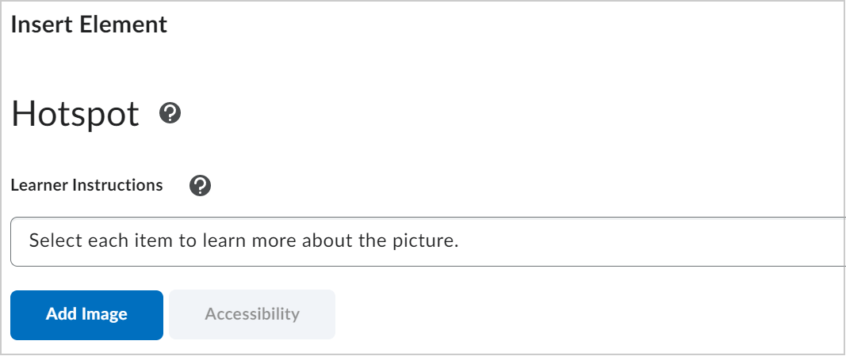
4. Click anywhere on the image to place a hotspot marker. The interface to build content associated with the hotspot appears to the right of the image.
5. In the right panel, select a hotspot to edit or add content. Each hotspot is labeled in the order in which you placed the marker.
6. You can rename the hotspot. Hotspot names are used for editing and for screen reader users.
7. In the **Hotspot Content** field, use the full HTML editor to add a description or more information, additional images, videos, and links to additional resources.  
   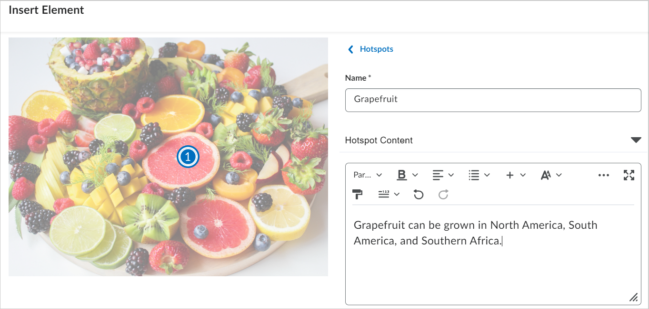  
   Figure: Entering a name and text for a hotspot.
8. Click **Hotspot Marker** to change the icon and color of a hotspot marker.  
   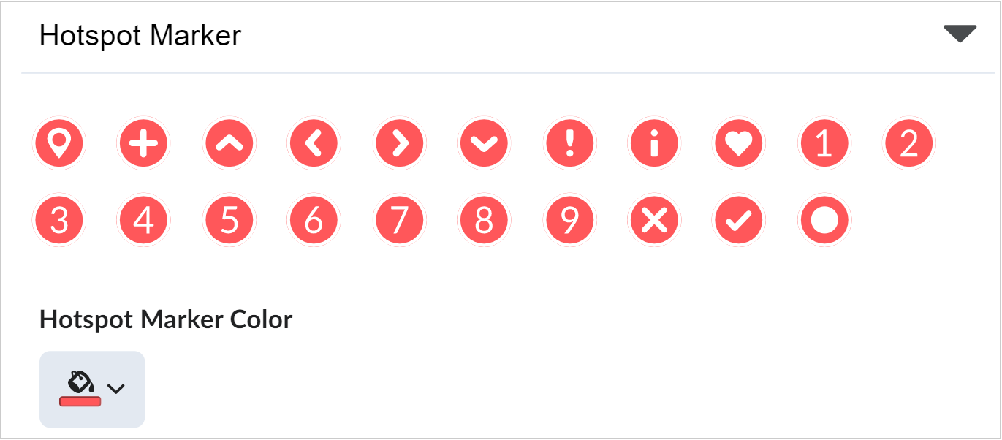
9. Select **Hotspots** to return to the hotspot selection option. Repeat steps 6-10 for all hotspots.
10. **Note:** You can insert up to nine hotspot markers for an image.
11. After adding all your hotspot markers, below **Learner Instructions**, click **Accessibility**.
12. Under the **Accessibility** heading, select one of the following:
13. **Accessible hotspots only:** Lets you add a micro alt tag for each hotspot to describe the part of the image associated with the hotspot. This is an ideal option when the position of the hotspot within the image or the contextual details of the image are not relevant to the learning.
14. **Fully accessible image:** Lets you split the image into a grid, allowing you to add a micro alt tag for each cell of the grid to describe all parts of the image. This is an ideal option when the position of the hotspot within the image or the contextual details of the image will inform the learning.
15. Add micro alt tags as required based on your Accessibility selection.  
    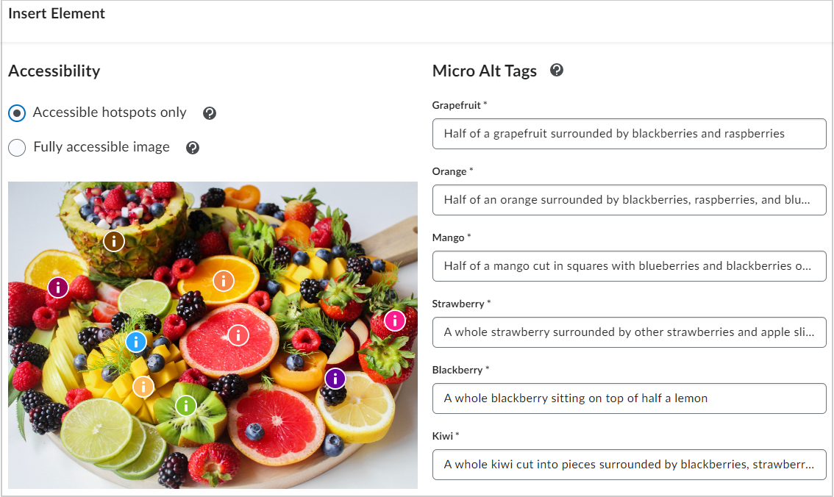
16. Click **Save and Insert** to add the Hotspot into the Content page.
17. Click **Save and Close**.
18. You have created a Hotspot Element.

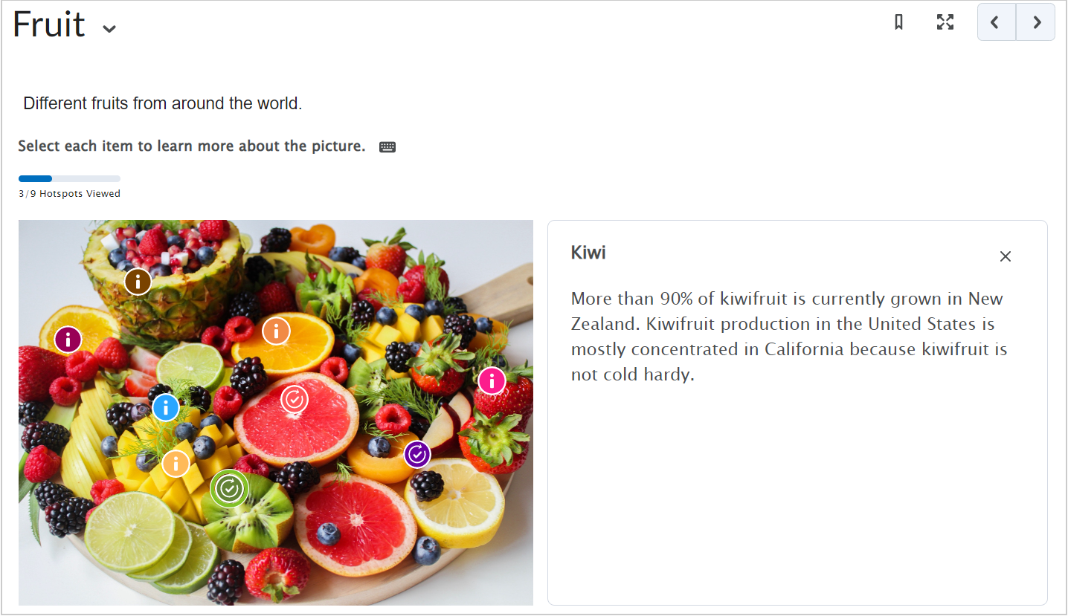

# Part 2: Edit Element or Practice Features in Content Files

1. Click **Edit HTML**.
2. Click anywhere on the element for the editing tools to appear.
   * Click the pencil icon to edit the element.
   * Click the trashcan icon to delete the element.
   * Click the arrows to move the element up/down on the content page.
   * Note: If you delete an element by accident and have not yet saved, you can use the ‘undo’ arrows in the editor toolbar.

1. Click **Save and Close**.