**Creating, Linking, and Using Brightspace Rubrics**

# Objectives

By following the guide, you will be able to:

Part 1: Create a New Rubric.

* Create a new Holistic Rubric with a single criterion.
* Create a new Analytic Rubric with multiple or weighted criteria.

Part 2: Link rubrics to discussion topics or assignments.

Part 3: Evaluate discussions and assignments using rubrics.

# Part 1: Create a New Rubric

1. Open the course where you wish to add the rubric.
2. Click **Course Admin**
3. Select **Rubrics**

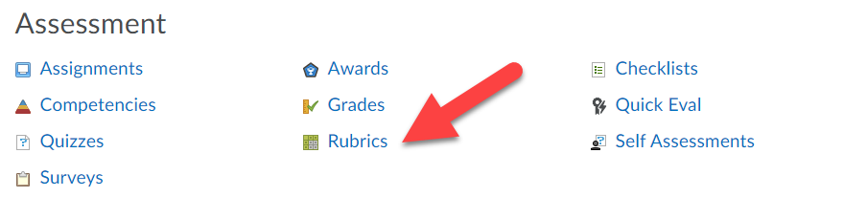

1. Click **New Rubric**
2. Enter a name for the rubric (e.g. Critical Analysis Paper)

## Create a Holistic Rubric with a Single Criterion

Holistic rubrics can be used to assess students on a single criterion with multiple levels.

1. Click the rubric **Type** drop-down menu and select **Holistic**

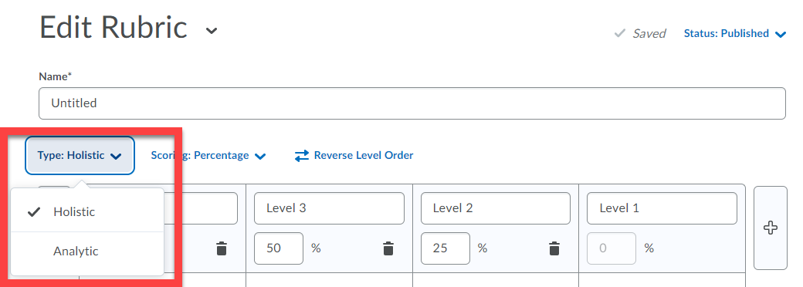

1. Click the **Scoring** method drop down menu and select the scoring type
   1. Choose  **No Score** if students will receive text-only feedback.
   2. Choose **percentage** if students will earn a grade.
2. Use the add icon Gray rectangle with a small plus sign inside to add new levels, or the trash icon Small trash bin to delete unneeded levels.
3. Click in each criterion box to edit level titles, percentages, and details:
   1. Edit level titles to indicate achievement (e.g. proficient, developing, beginning).

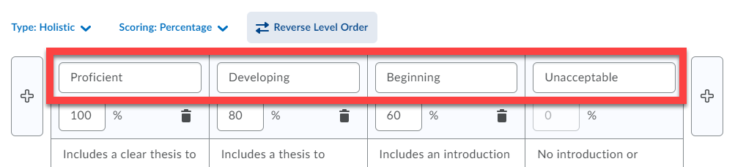

* 1. Edit level percentages to award a score for each level of achievement.

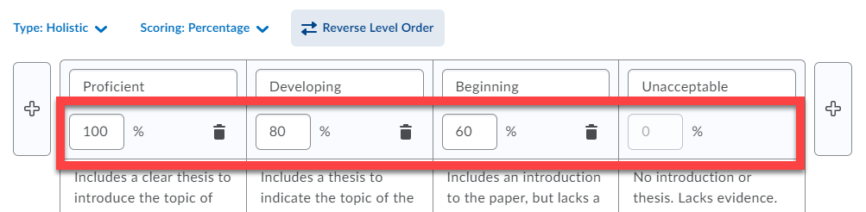

* 1. Add details so students know what is needed to achieve each level.

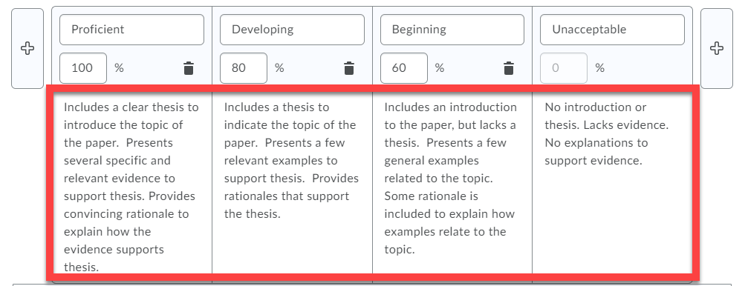

1. Click **Options** to change **Rubric Visibility** and control if students can view the rubric.
2. Click **Close**

## Create an Analytic Rubric with Multiple Criteria

Analytic rubrics can be used to assess students on multiple criteria. Criteria can be weighted, if desired, to emphasize some criteria over others.

1. Click the rubric **Type** drop-down menu and select **Analytic**

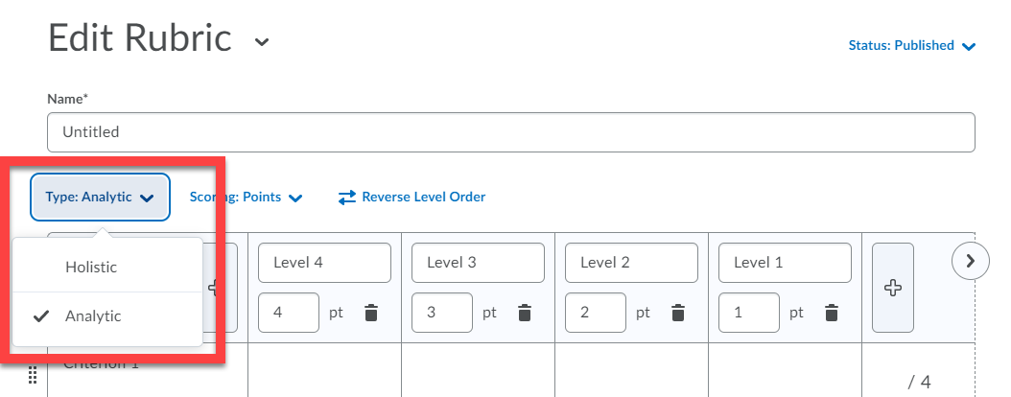

1. Click the **Scoring** method drop-down menu and select the scoring type.
   1. Choose **No Score** to provide text-only feedback.
   2. Choose **Points** to distribute points evenly across all criteria.
   3. Choose **Custom Points** to assign a specific weight to each criterion.
2. Use the add icon Gray rectangle with a small plus sign inside to add new levels, or the trash iconSmall trash bin to delete unneeded levels.
3. Click **Add Criterion**  to insert additional criteria or click the trash icon  to delete unneeded criteria.
4. Click each box to edit criterion name, level titles, percentages, and details.
   1. Edit the criteria names to identify expected components of performance.

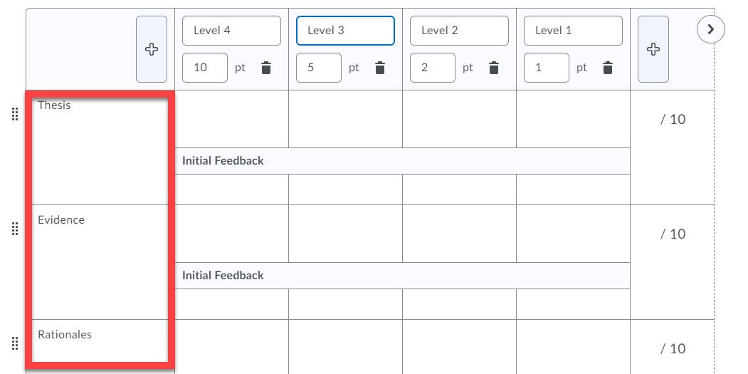

* 1. Edit level titles to indicate achievement (e.g. proficient, developing, beginning).

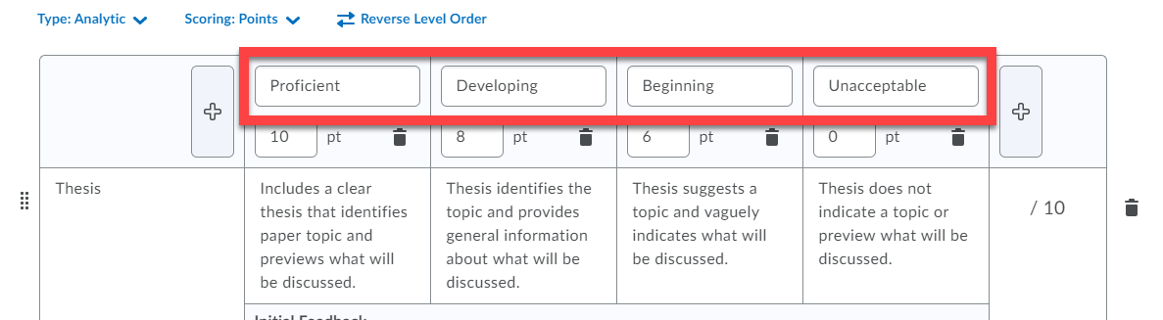

* 1. Edit level points to award a score for each level of achievement.

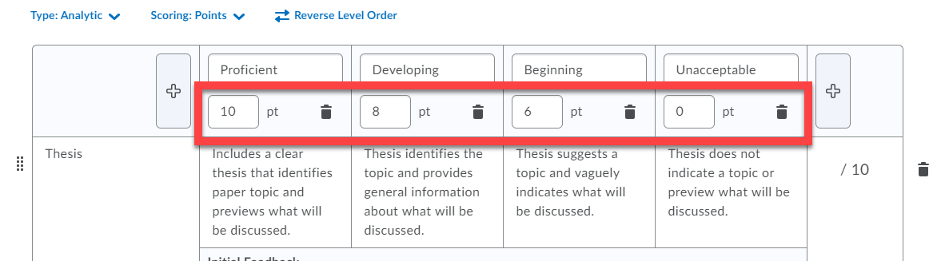

* 1. For a weighted rubric (remember to use the **Custom Points** scoring method), adjust the weight for each criterion as desired.

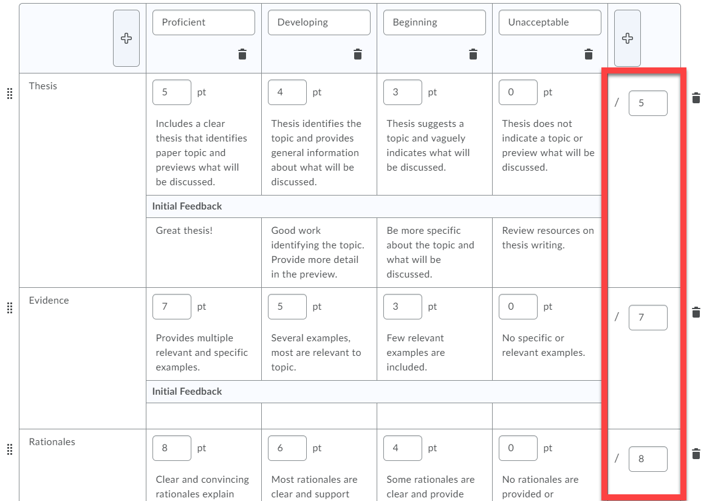

* 1. Add details so students know what is needed to achieve each level.

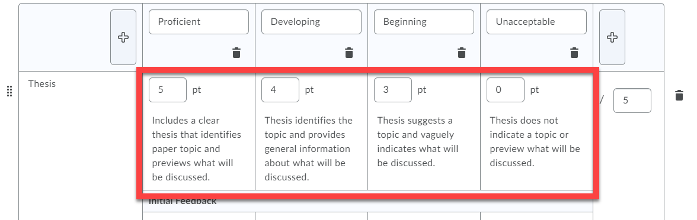

* 1. Add initial feedback, if desired, to provide immediate feedback related to each level.

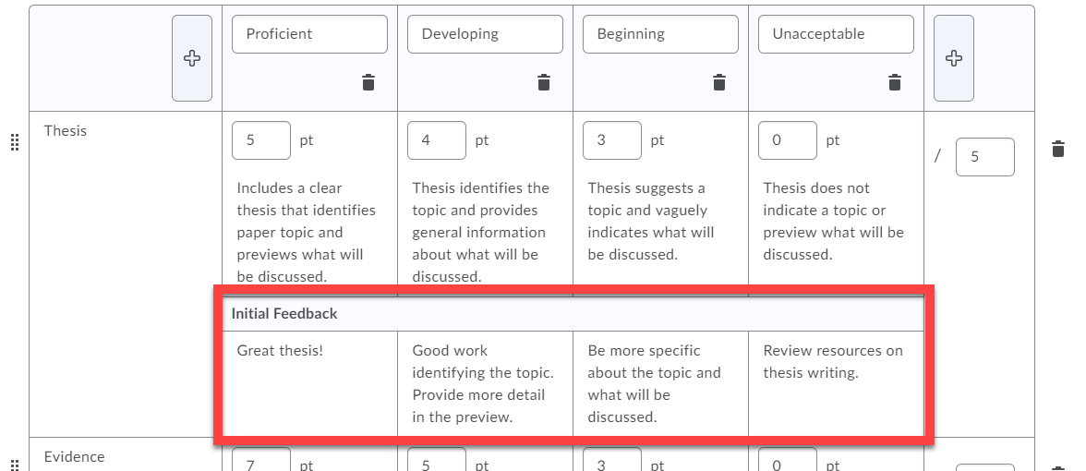

1. Add more criteria groups if needed.
2. Edit the **Overall Score**
   1. The Overall Score area provides feedback to each student based on their score on the activity.
   2. The Overall Score is *not* associated with the gradebook. It is a global indication about student performance based on performance thresholds set by the instructor.
   3. Click the Overall Score box to change level names, adjust point thresholds, and add or remove levels.

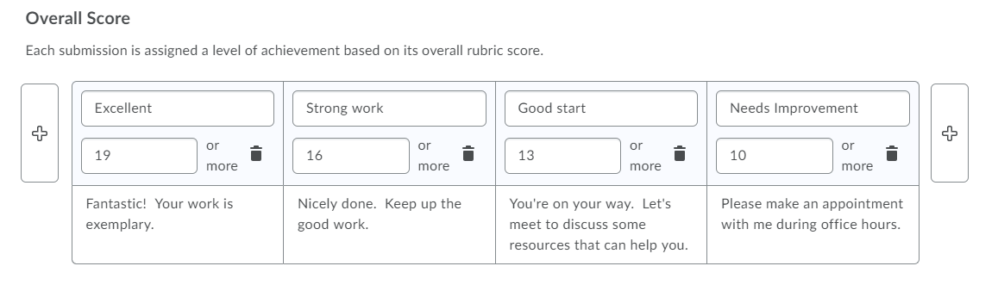

* 1. In the example above, if a student scores 19 points or more, they will meet the threshold for “Excellent.”

1. Click **Options** to change **Rubric Visibility** and control if students can view the rubric.
2. Click **Close**

# Part 2: Link Rubrics to Discussion Topics and Assignments

Connect your rubric to discussion topics or assignments to help students understand what is expected of them and to make grading more efficient and consistent.

## Add a Rubric to a Discussion Topic

1. Click **Course Tools** and select **Discussions**.
2. Locate the discussion topic, then click the drop-down arrow and select **Edit Topic**.
3. Click the **Assessment** tab
   1. To link an existing rubric:
      1. Click the Add Rubric button.
      2. Check the box next to the rubric you wish to add.
      3. Click the **Add Selected** button.
   2. To create a new rubric:
      1. Click the [Create Rubric in New Window] link.
      2. Complete the steps in Part 1 of this guide.
4. Click **Save and Close**.

## Add a Rubric to an Assignment

1. Click **Course Tools** and select **Assignments**
2. Locate the assignment, then click the drop-down arrow and select **Edit Assignment**.
3. Click the **Evaluation & Feedback** menu.
4. Click the **Add Rubric** drop-down menu.
   1. To link an existing rubric:
      1. Choose **Add Existing**.
      2. Check the box next to the rubric you wish to add.
      3. Click the **Add Selected** button.
   2. To create a new rubric:
      1. Choose **Create New**.
      2. Complete the steps in Part 1 of this guide.
5. Click **Save and Close**.

# Part 3: Evaluate Discussion Topics and Assignments using Rubrics

## Assess Discussion Topics using Rubrics

1. Click **Course Tools** and select **Discussions**.
2. Locate the discussion topic you want to grade, then click the drop-down menu and choose **Assess Topic**.
3. Click **Topic Score** to evaluate each student’s discussion contribution.
4. Review the student’s threads and replies.
5. For each criterion, select the level that corresponds with the student’s performance:

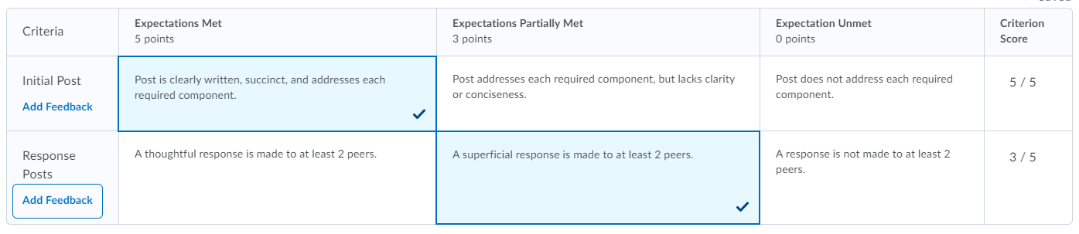

1. If desired, click **Add Feedback** on each criterion to provide specific feedback.

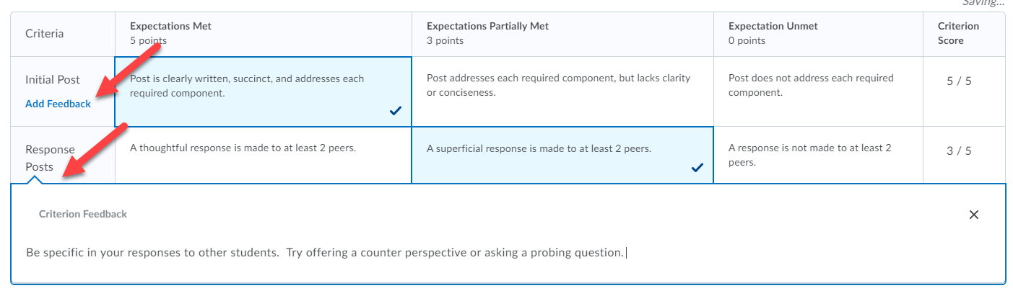

1. Add **General Feedback**, if desired.
2. Click **Publish**
3. Repeat steps 3 – 8 for remaining students.

## Assess Assignments using Rubrics

1. Click **Course Tools** and select **Assignments**.
2. Locate and click on the assignment you want to grade.
3. Click on the name of a submission to evaluate the student’s work.
4. In the grading menu, locate the rubric and click to open.

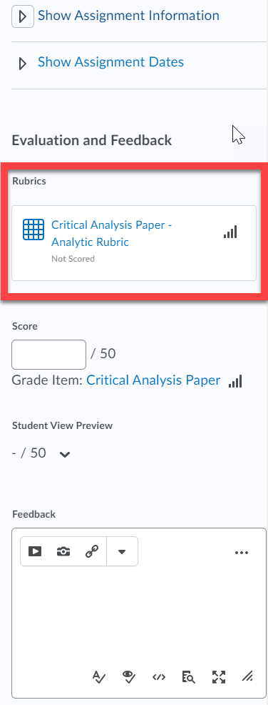

1. For each criterion, select the level that corresponds with the student’s performance.

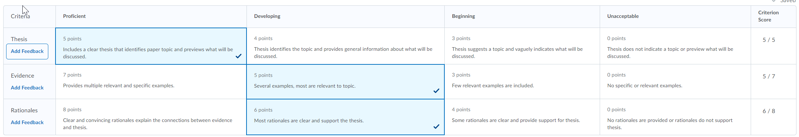

1. If desired, click Add Feedback on each criterion to provide specific feedback.

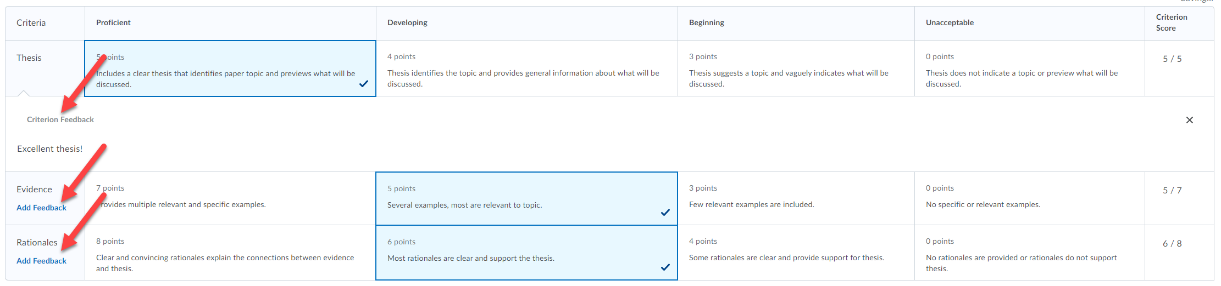

1. Click **Close**.
2. Add **General Feedback**, if desired.
3. Add grading annotations to the student’s submission, if desired.
4. Click **Publish**.
5. Repeat steps 3 – 10 for remaining students.