

**Steps to Start the Banner Defined Printer for Student Schedules**

Logon to the Banner system. In the Search box enter: **SFRSCHD,** Click Go.

A panel called GJAPCTL will display. You are in the Printer Control block. In the Printer field click on the ellipses. Find your office printer and click ok.

Next Block (in the lower left corner), into the Parameter Values Block.

# Initial Setup of Parameter Set for SFRSCHD

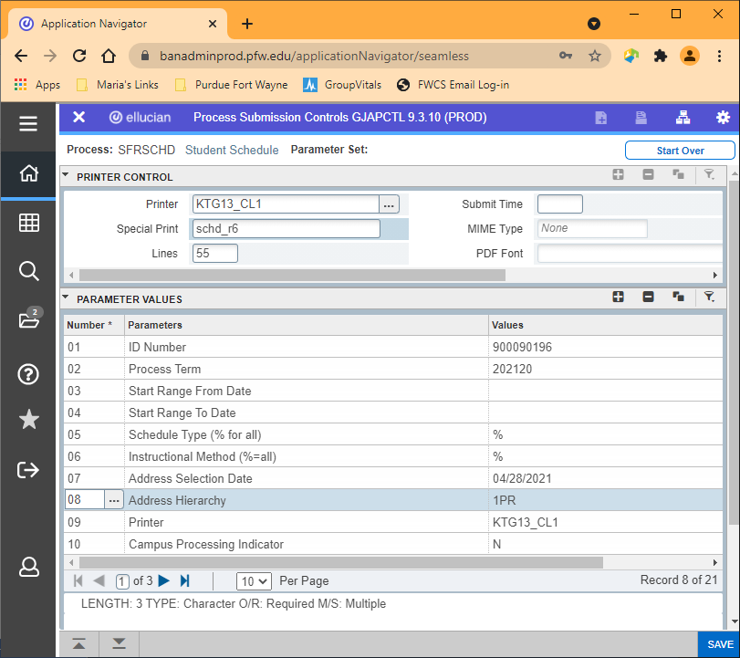

COLLECTOR

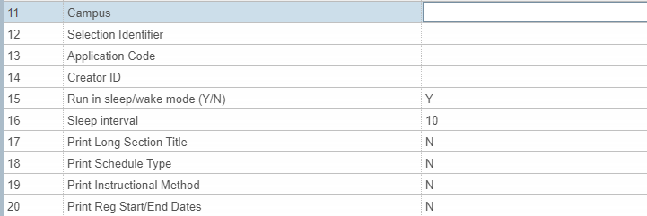



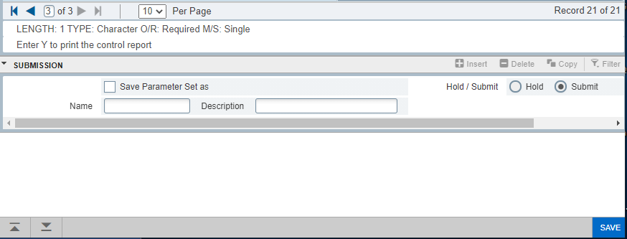

See Parameters on the Next Page

|  |  |  |
| --- | --- | --- |
| Number | Parameters | Values |
| 01 | ID Numbers | Enter COLLECTOR in all caps |
| 02 | Process Term | Enter term desired |
| 03 | Start Range From Date | Leave at default |
| 04 | Start Range to Date | Leave at default |
| 05 | Schedule Type (% for all) | % |
| 06 | Instructional Method (%=all) | % |
| 07 | Address Selection Date | Enter “T” for today’s date |
| 08 | Address Hierarchy | Enter 1PR |
| 09 | Printer | Click on Values ellipses to see list of printers. Select your main office printer from this list. Double click or click ok to bring value back. |
| 10 | Campus Processing Indicator | N |
| 11 | Campus | Leave at default |
| 12 | Selection Identifier | Leave at default |
| 13 | Application Code | Leave at default |
| 14 | Creator ID | Leave at default |
| 15 | Run in sleep/wake mode | Enter Y |
| 16 | Sleep Interval | Enter 10 |
| 17 | Print Long Section Title | Leave at default |
| 18 | Print Schedule Type | Leave at default |
| 19 | Print Instructional Method | Leave at default |
| 20 | Print Reg Start/End Dates | Leave at default |
| 21 | Print Control Report | Leave at default |

Next Block (lower left corner), into the Submission Block. Check the Save Parameter Set As box. Enter a name for this parameter set in the **Name:** box and a brief description in the **Description:** box. Click Save.

**Reusing Parameter Sets For SFRSCHD**

Once you have a parameter set saved, you can reuse this parameter set by entering SFRSCHD in the Search box. Click on the ellipses icon next to the Parameter Set field.



A list of saved parameter sets for the process selected is displayed. Double-click on the desired parameter set or highlight the desired parameter and click Select (lower right).

The GJAPCTL screen will reappear. Click **Go** to populate the fields.

**Parameters to Change**

For SFRSCHD you will need to select your office printer in the top Printer field and change Parameter 07 - Address Selection Date every day to today’s date. You will need to update Parameter 02 - Process Term whenever you wish to change the term for which you are printing schedules. Always verify the other parameters are correct, especially the printer.

Next Block to the Submission Block once all your updates have been made. Click in the Save Parameters box, and click on the Save icon to make parameter set changes.

**Others Printing Schedules**

If anyone in your department wants to print schedules to your Banner defined printer they must select the same printer code in the Schedule fields of the SOADEST screen as entered in Value 05-Printer field of your parameter set. The SOADEST screen will come up automatically when SFAREGS is first opened in a session.

**Printing Schedules for Multiple Terms**

The parameters used for SFRSCHD are term specific and do not allow for multiple terms.

**Change Printer Parameters Once Started – Stopping Printer**

Should you need to change parameters after you have started the printer for the day, you will first need to stop the printer and then start with new parameters. Follow these steps to do so:

In the Search box, enter: **GJASWPT**

In Process field, click on the ellipses for a list of values: select **SFRSCHD** for schedules

In Printer field, click on the ellipses to view list of printers. Select your printer by double clicking on it or select your printer and click Select (lower left corner).

Click Go to populate screen

The Continue to Run parameter must be set to **N**

Click Save to stop printer

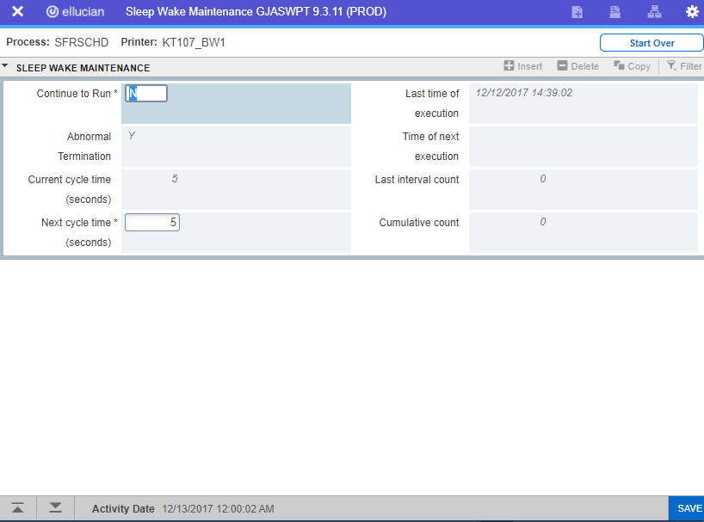

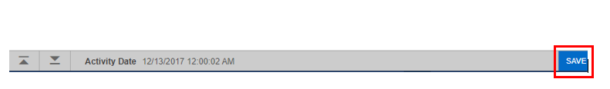

Once printer has been stopped, follow your instructions under **Reusing Parameter Sets** and make the necessary adjustments.