

STUDENT RESEARCH

& CREATIVE

ENDEAVOR

SYMPOSIUM

DEVELOPING

A GOOD POSTER

Dean Emerita Cheryl Truesdell, Helmke Library

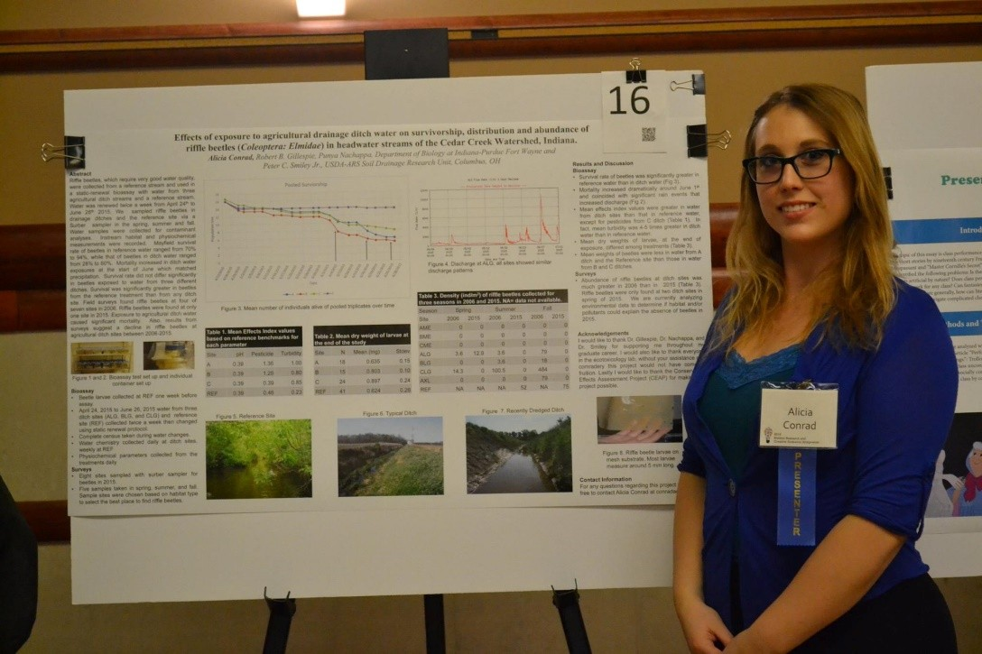

methods of presenting

PARTS OF THE POSTER

•

Disciplines have different

information

•

Include sections that are

relevant to **your** project

•

Consult your faculty mentor in

determining the poster

contents

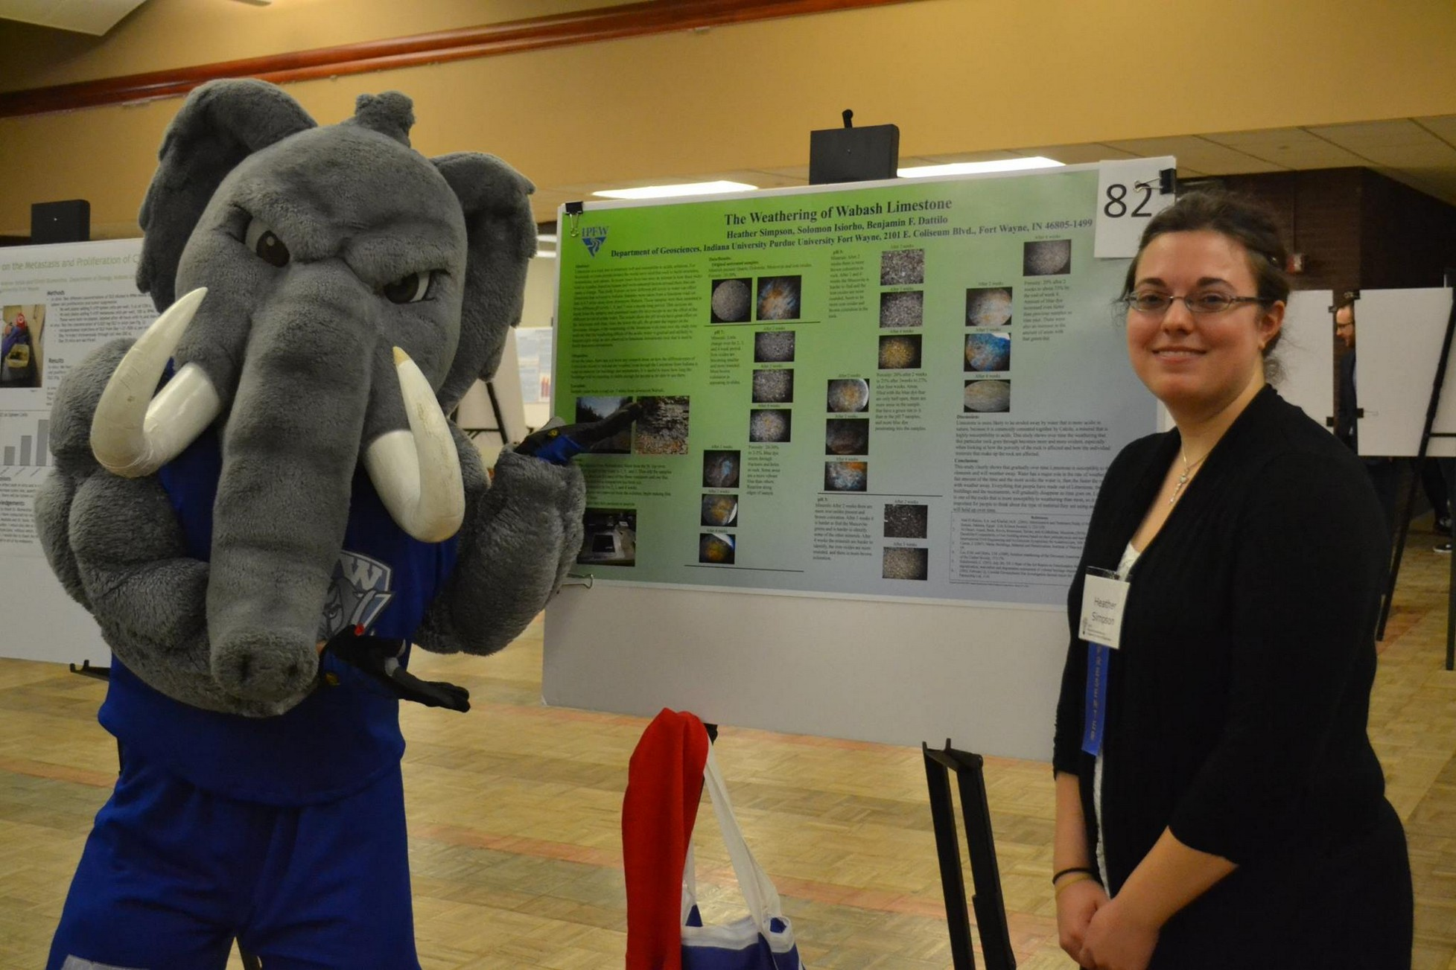

•

MOST COMMON PARTS

OF THE POSTER

•

Title

•

Abstract

Methods

•

Results

•

Conclusion

•

Literature Cited

•

Acknowledgements

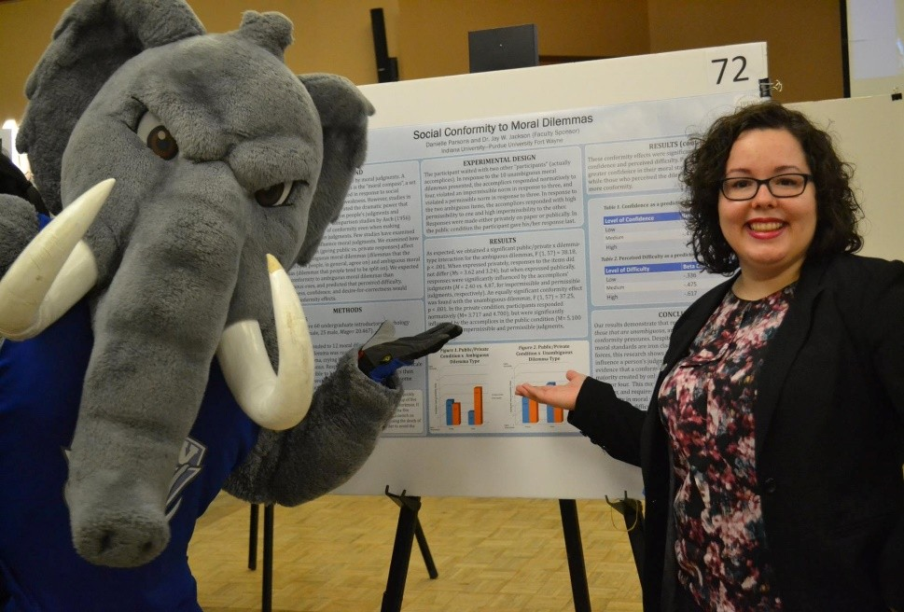

•

TITLE

•

**Should contain the keywords of the**

**project**

•

**First text observers will read**

**Primary search field for online discovery**

**Sample:** Do Nonprofit Nursing Homes Perform Better

Than For-Profit Nursing Homes? Empirical Evidence in

Indiana

**Sample:** Puerarin: from the roots of kudzu, an invasive

plant, to the front lines in modulating stress within

farmed salmonids.



ABSTRACT

•

**Briefly outlines**

**research/creative project**

•

**Clear, concise, precise**

**wording**

•

**Informative, descriptive,**

**compelling**



▪

**What are the reasons behind this project?**

▪

**What did you set out to do?**

▪

**What were the study’s hypotheses or**

**questions?**

▪

**Why it is important?**

INTRODUCTION

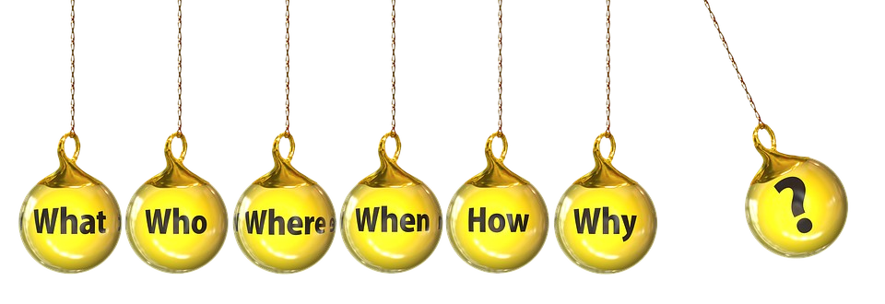

▪

Methodology

▪

What did you do?

▪

What techniques did you use?

METHODS



▪

How was the data analyzed?

▪

What did you find?

▪

What does your data mean in the real

world?

RESULTS



What conclusions did you draw from the

▪

analysis?

▪

Is additional work needed?

▪

What are the implications?

▪

What are the future directions?

CONCLUSION

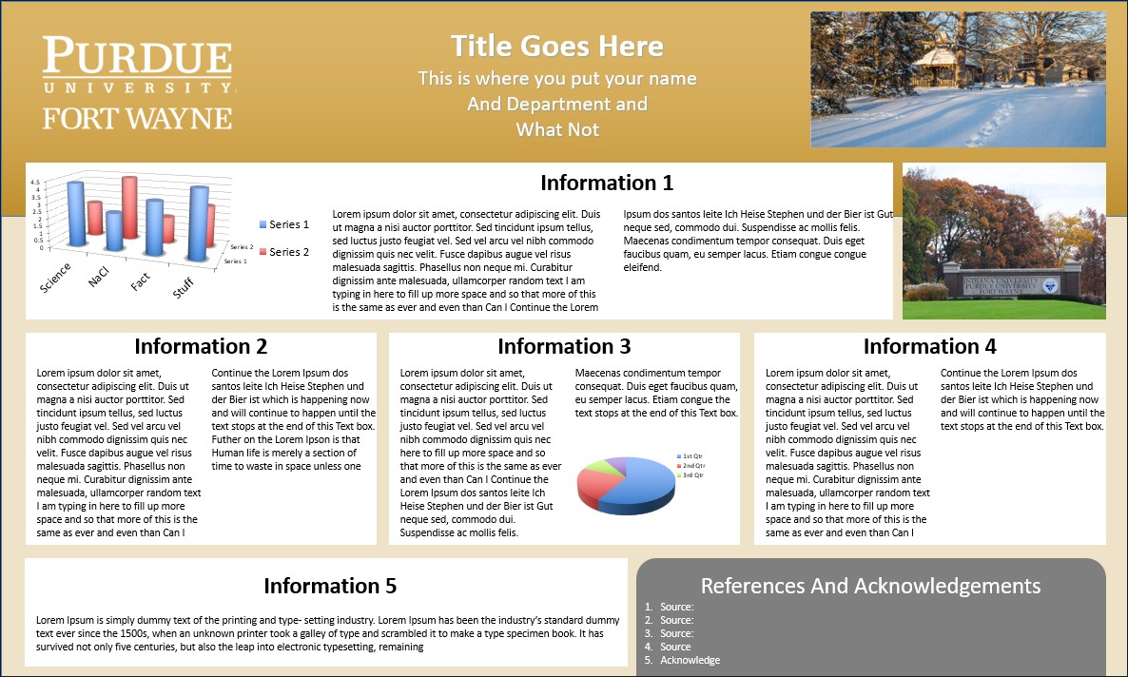

▪

List significant sources consulted

LITERATURE CITED

You may put them here

or any place you feel

comfortable putting

them on the poster.



Acknowledge any **partner(s) or**

▪

**funding/resources** support

ACKNOWLEDGEMENT



▪

Learn about the 23

rd

Annual Student Research and

Creative Endeavor Symposium Posters and register at:

**https://www.pfw.edu/centers/irsc/research-sympos**

**ium/**

GET STARTED

